**Enlace al repositorio Github**

https://github.com/jmrendonr/Proy-Ciclo4-grupo1-e-learning.git

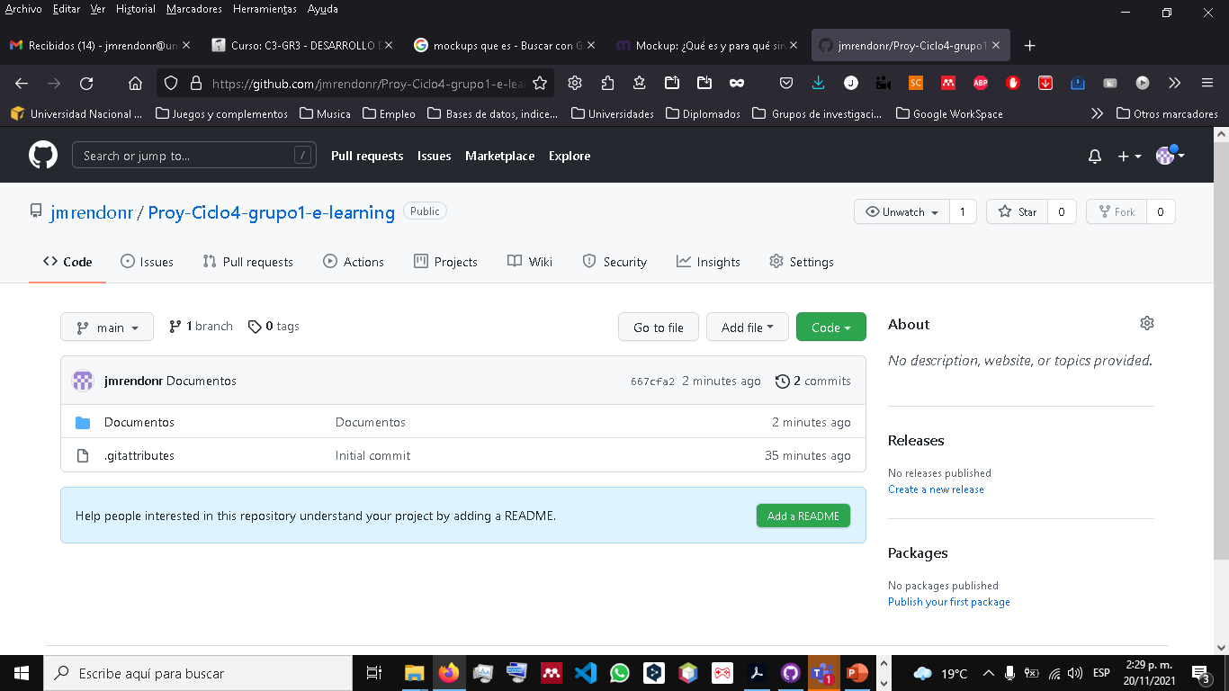

**Enlace al drive compartido**

https://drive.google.com/drive/folders/19FUHZ1yh_cE8ejr--k-zLzubrzFUN-Uw?usp=sharing

